1. StudentXMLSchema:

//getStudentInformation(stuid)

//return a Student Object

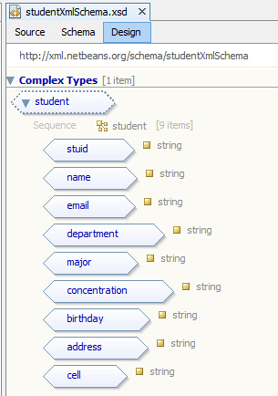

C:\Users\YIYI\AppData\Roaming\Tencent\Users\1017595623\QQ\WinTemp\RichOle\)B4]HKXNU4]HVSR`SF3[QIU.jpg

C:\Users\YIYI\AppData\Roaming\Tencent\Users\1017595623\QQ\WinTemp\RichOle\FTMMZM8$6Q)C4)FM_4Z9~SN.png

1. PermissionXMLSchema:

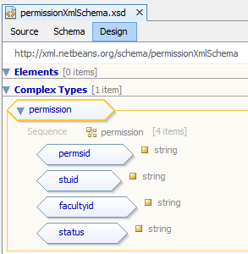

1. enrollmentXMLSchcema:

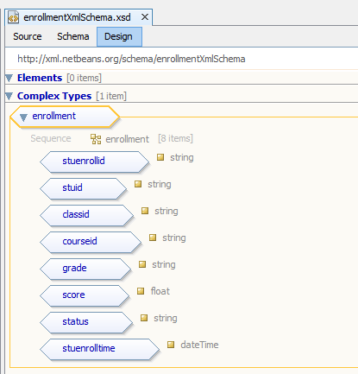

1. departmentXMLSchema:

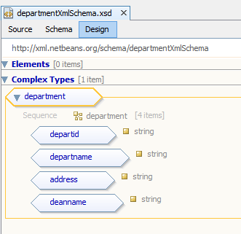

1. major:

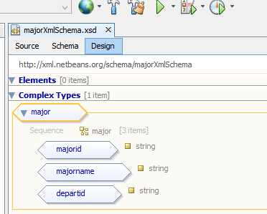

1. faculty:

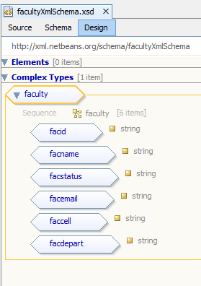

1. class:

//getClassInformation(String classid)

//return a Class Object

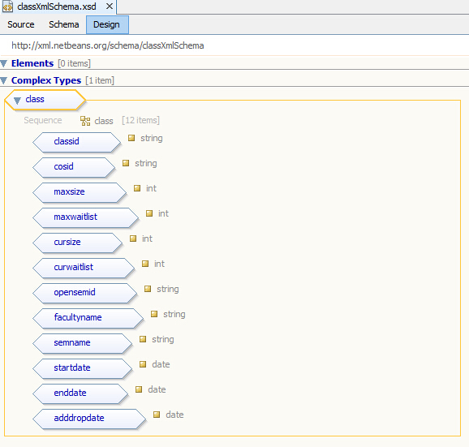

C:\Users\YIYI\AppData\Roaming\Tencent\Users\1017595623\QQ\WinTemp\RichOle\MF8IL[_K5]@ZLSKP~ODO5AS.png

C:\Users\YIYI\AppData\Roaming\Tencent\Users\1017595623\QQ\WinTemp\RichOle\KCO1MYF2{TZGY7V$$~_L({N.png

1. course:

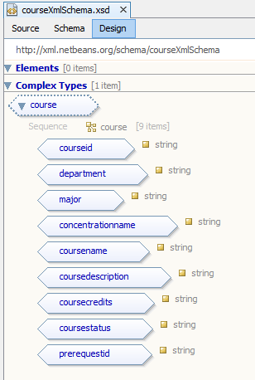

1. semester:

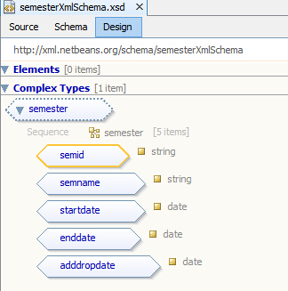

1. prereqestment:

//getClassPrerequestment(String classid)

//return a Prerequestment Object

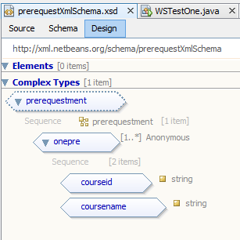

C:\Users\YIYI\AppData\Roaming\Tencent\Users\1017595623\QQ\WinTemp\RichOle\J(OGF]_3F@1XLWRE(]IN8)N.png

C:\Users\YIYI\AppData\Roaming\Tencent\Users\1017595623\QQ\WinTemp\RichOle\5M{MS03C)ZAV]F~31LMYP$8.png

1. studentEnrollment

//getStudentEnrollment(String stuid)

//return a StuEnroll Object including a list of classes

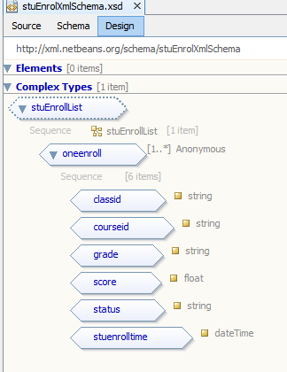

1. checkAndRegistration

//checkAndRegistration()

//return a list of classes (0 - 4)

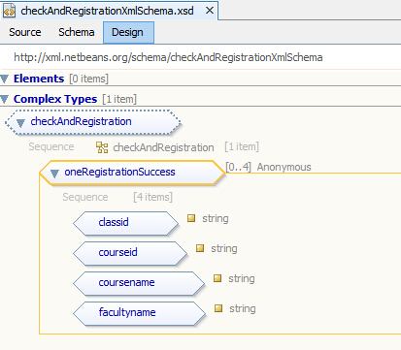

C:\Users\YIYI\AppData\Roaming\Tencent\Users\1017595623\QQ\WinTemp\RichOle\_KRAO6`HUMTEL0@EMJ1_{V1.png

C:\Users\YIYI\AppData\Roaming\Tencent\Users\1017595623\QQ\WinTemp\RichOle\DO4}]XF]H35EDRPIF2R`ZJI.png